PYTEST FRAMEWORK
In general, pytest is invoked with a command pytest. This will execute all tests in all files whose names follow the form test_*.py or \*_test.py in the current directory and its subdirectories
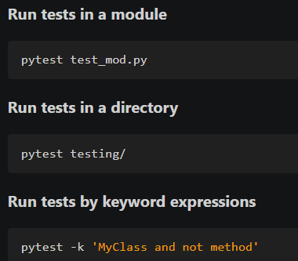
The example above will run TestMyClass.test_something but not TestMyClass.test_method_simple
PYTEST FIXTURES
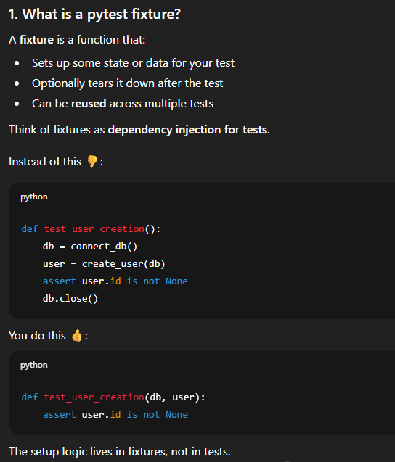
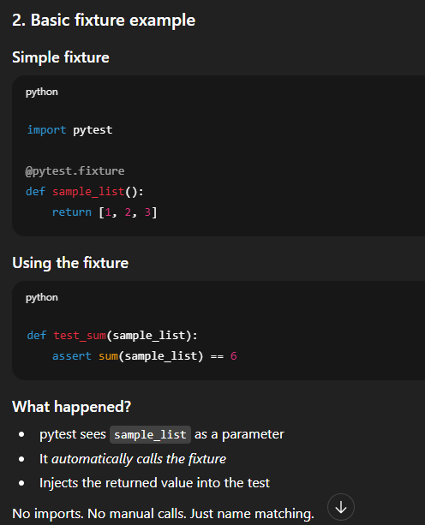
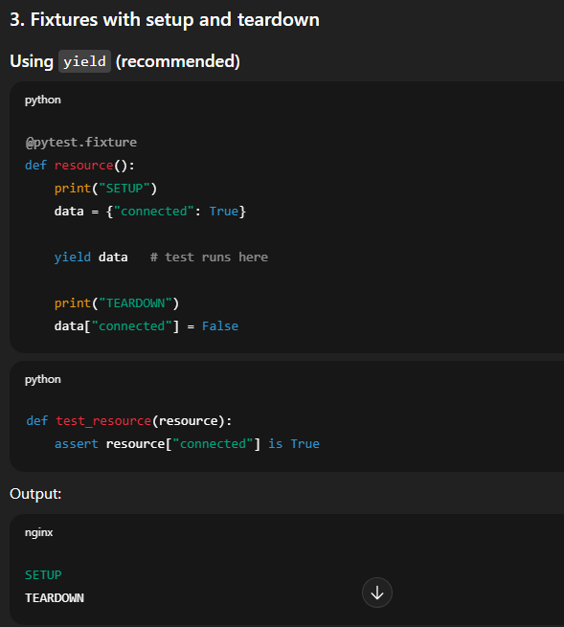
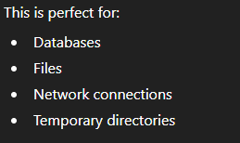
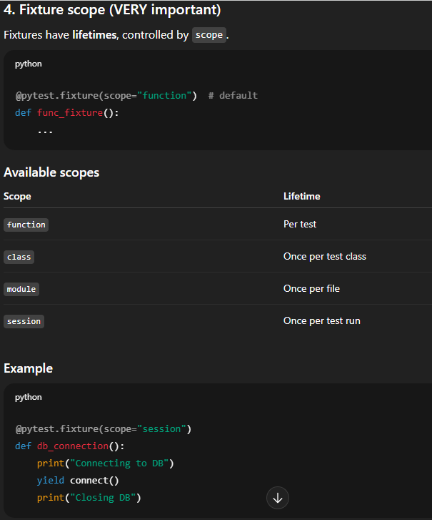
Here all tests will share one DB connection.
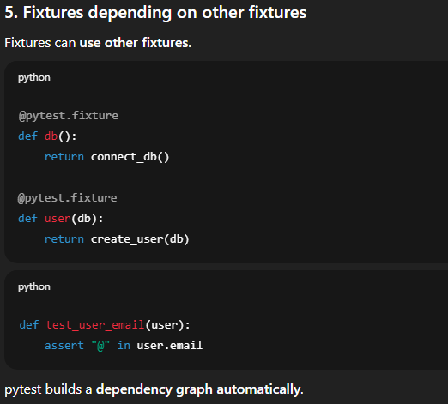
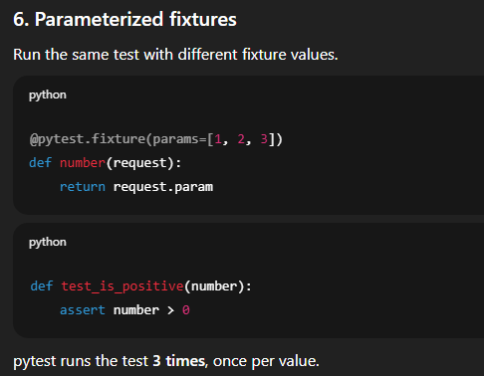
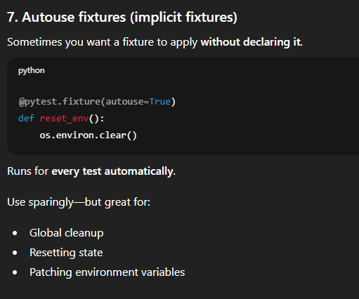
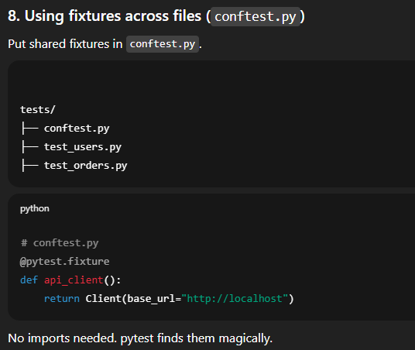
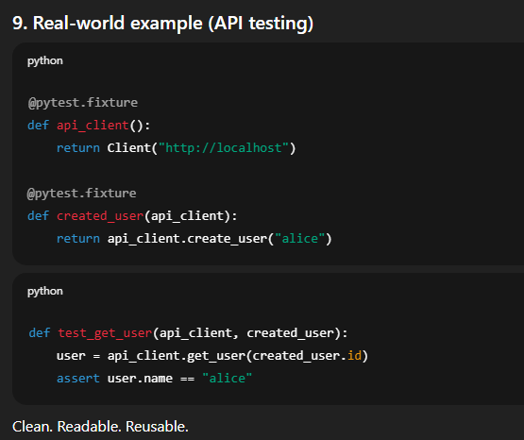

SCOPE OF FIXTURE:
Fixtures like those require network connection will take some time. So we can add module scope to such fixtures. We can save such fixtures in conftest.py, pytest can automatically recognize them.
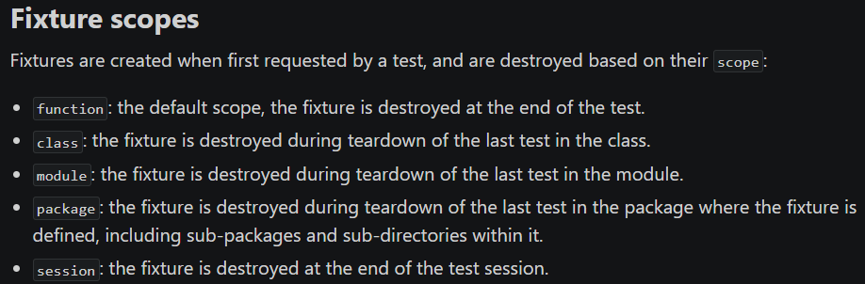

YIELD in fixtures:
To automatically close the resources, we can mention yield in the fixtures and the closure will start from reverse order in those fixtures. For example, we send an email from one user to other user, first the recipient resources are closed and then then the sent person. The teardown code is placed after the yield keyword. We write the fixtures in that order so by looking at yield keyword the pytest closes the last fixture first.

PARAMETRIZING FIXTURES:
Running the same test multiple times with different fixture values. Instead of writing many similar tests, pytest does the repetition for you. We can access the parameters with request.param

